**Supplementary S1: Study Area in India – Odisha, Andhra Pradesh and Tamil Nadu**

Figure : Study Area in India: 31,088 coastal villages across 27 districts in three states—6 in Odisha (yellow), 9 in Andhra Pradesh (green) and 12 in Tamil Nadu (blue). Map made in ArcGIS Pro, using Census of India 2001 boundaries (1). This region has been exposed to 16 storm surges recorded in the period 1885-2015 (SURGEDAT)(2) depicted in red dots, with the earliest in 1964 and most recent in 2011.



Figure : Aquaculture area as land share across coastal districts in 2025. Comparing the surge affected districts with districts with higher concentration of aquaculture (also see Prasad et al. (3) for SAR based estimates that show similar concentrations) shows strong association between the two. Map made in ArcGIS Pro, using Census of India 2001 boundaries (1). This region has been exposed to 16 storm surges recorded in the period 1885-2015 (SURGEDAT)(2) depicted in red dots.

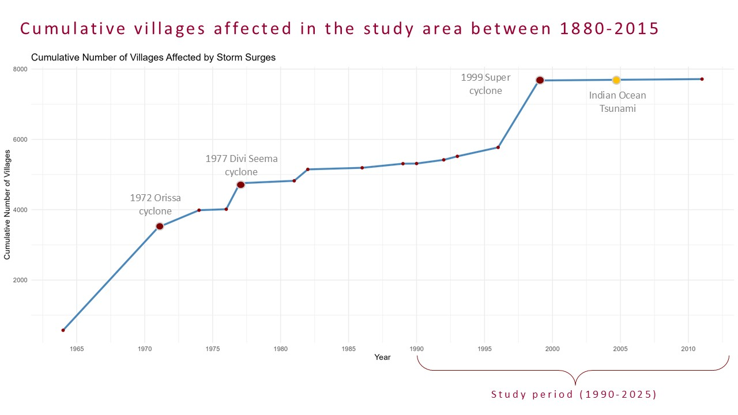

Figure : Cumulative number of villages affected by storm surges in the study area between 1885-2015. Note: Villages affected by the Indian Ocean tsunami in 2004-05 have not been included here or in the analysis, since a tsunami is fundamentally a geotectonic event and not a weather/climatic event. A tsunami may still have similar implications on environmental losses as does a surge.

**Supplementary S2: Aquaculture growth globally and in India (states and select districts)**

Land-use change to aquaculture has expanded substantially across coastal India since the early 1990s, with a particularly sharp and sustained increase after 2010, alongside a similar global uptick.

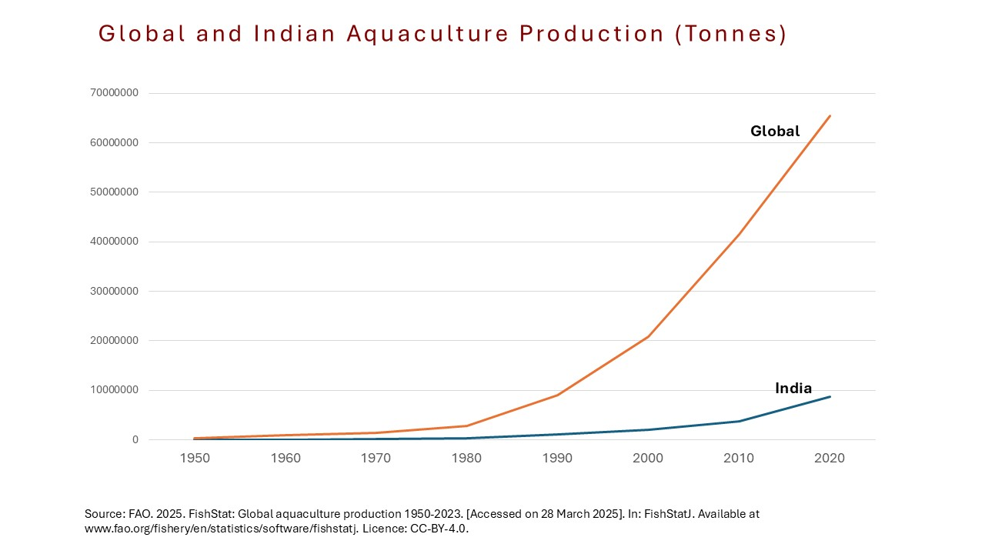

Figure : Global and Indian aquaculture production (in Tons). Graphic made using data sourced from FishStat Database (4).

Figure : Average village land share used as aquaculture (1990-2025). The upward trend shows an overall increase in aquaculture land share in the study region (see Supplementary S1). Aquaculture area is estimated by conducting supervised land use land cover classification on Landsat 5 (1990-2012) and Landsat 8 (2013-2025) satellite images (Supplementary S13). Satellite images for the study area for years 1998, 1999, 2002, 2003, and 2012 are either missing or have significant cloud cover and hence dropped from the analysis.

Figure : Regional Variation in Aquaculture Growth (1990-2025). Villages in Andhra Pradesh had a higher aquaculture land share at the beginning of the study period, and have increased steadily. Tamil Nadu and Odisha had similar levels of aquaculture up until 2005, but villages in Odisha have since seen a sharper increase in aquaculture land share. Aquaculture area is estimated by conducting supervised land use land cover classification on Landsat 5 (1990-2012) and Landsat 8 (2013-2025) satellite images (Supplementary S13). Red dots specify the various storm surges across the three states. Note: Tamil Nadu also experienced the Indian Ocean Tsunami in 2004-05, but since it is not a storm surge, it has not been included in this analysis.

Following are the within-state select district-level comparisons that replicate the national and state experience of increased aquaculture concentration in surge affected areas.

Figure : Comparing two select districts within the state of Andhra Pradesh – Krishna District that was affected by storm surges in 1977 and 1990, and Srikakulam District that has remained unaffected by a storm surge. The former shows higher aquaculture levels in 1990 as well as a steeper growth over the study period. The latter shows a very low aquaculture uptake change over the years.

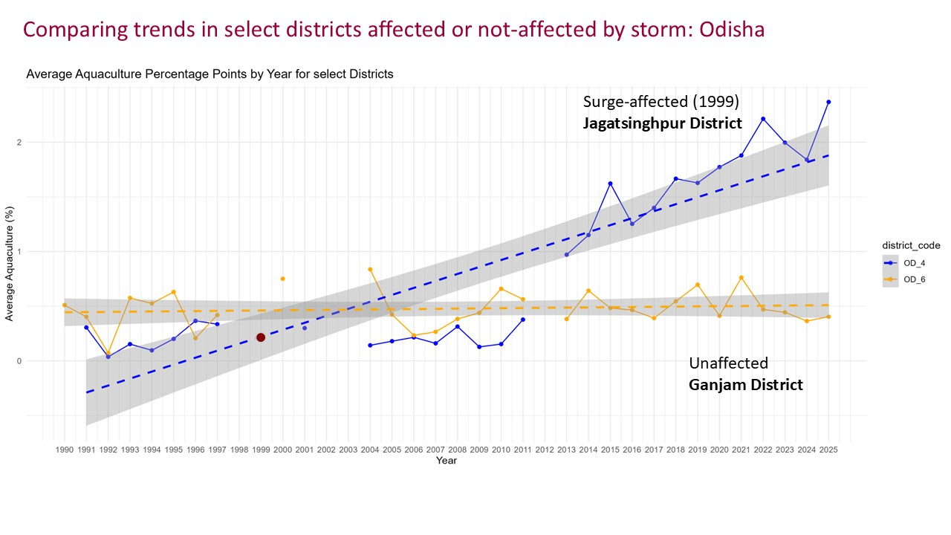

Figure : Comparing two select districts within the state of Odisha – Jagatsinghpur District that was affected by a storm surge in 1999, and Ganjam District that has remained unaffected by a storm surge. Both had similar aquaculture levels until 2010, but Jagatsinghpur witnessed a sharper increase in the following two decades while Ganjam remained steady.

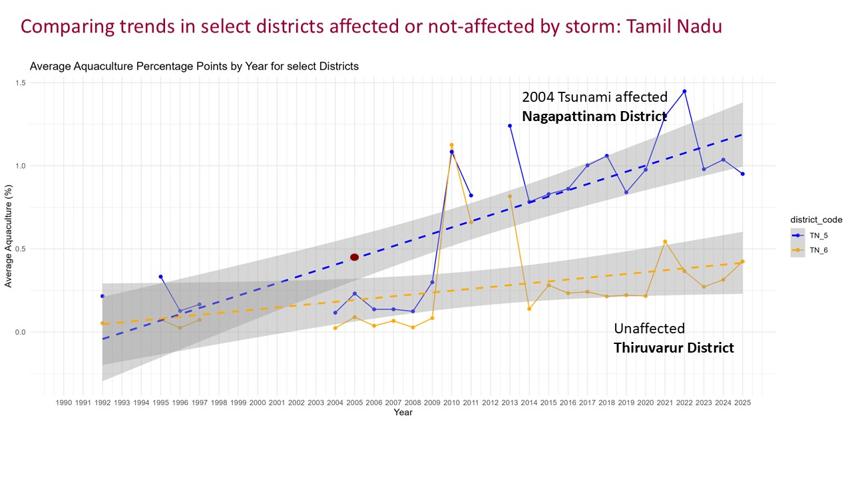

Figure : Comparing two select districts within the state of Tamil Nadu – Nagapattinam District that was affected by a Tsunami in 2004, and Thiruvarur District that was much less affected due to its indented location on the coast. Both had similar aquaculture levels until 2012, but Nagapattinam witnessed a sharper increase in the following two decades while Thiruvarur witnessed a much slower increase.

**Supplementary S3: Aquaculture and Salinity changes with distance from the sea**

|  |  |
| --- | --- |
|  | **All villages** |
|  | **Villages within 60km from the coast** |
|  | **Villages within 30km from the coast** |
|  | **Villages within 10km from the coast**   |

*Figure 10:* *Aquaculture land share change between storm affected and unaffected villages by distance from the sea. The top panel includes all villages in the study area, second panel includes only those that are within 60km from the coast, third panel includes villages that are within 30km of the coast and the fourth panel only includes villages within 10km from the coast. As distance to the coastline decreases, overall prevalence of aquaculture land change increases, however, places affected by storms (in blue) continue to have higher aquaculture land share as compared to villages unaffected by surges (in yellow).*

|  |  |
| --- | --- |
|  | **All villages** |
|  | **Villages within 60km from the coast** |
|  | **Villages within 30km from the coast** |
|  | **Villages within 10km from the coast**   |

Figure : Average saline area in storm affected and unaffected villages by distance from the sea. As distance to the coastline decreases, overall prevalence of salinity increases slightly, however, places affected by storms (in blue) continue to have higher saline area share as compared to villages unaffected by surges (in yellow). Salinity is estimated using CoSal Framework (5), where 1900 microS/cm of electrical conductivity of the soil is considered as the salinity threshold. This threshold is found to affect rice production negatively (6).

**Supplementary S4: Relationship between Salinity and Storm Surge**

Table 1: Coefficients from three panel regression models, Salinity Models 1-3, where the dependent variable is the percentage of land estimated as saline in each village. Model 1 is a one-way fixed effect model (year), that estimates the average effects of storm surge shocks on salinity comparing villages with each other in a particular year. Model 2 is a two-way fixed effect model, which compares the effect of storm on salinity across a single village over time. Model 3 is a full-specification model, with two-way fixed effects as well as place-time varying controls, such as rainfall and population density as a proximate for urbanization. The results suggest that, overall, storm surges are positively associated with long-term salinity exposure; villages that experience more frequent surges tend to have higher average salinity levels (Model 1). Examining changes within villages over time (Model 2), however, reveals that average salinity declines by 0.066 units in the immediate post-surge period relative to pre-surge levels. This short-term decrease may reflect temporary leaching or flushing effects, behavioral responses such as land fallowing, or increases in soil moisture following inundation.

**Supplementary S5: Effects of Storm Surge and Salinity on Aquaculture**

Table 2 : Coefficients from five panel regression models, Aquaculture Models 1-5, where the dependent variable is the percentage of land classified as aquaculture in each village. All are two-way fixed effect models for village and year, and have standard errors clustered at the village level. Model 1 estimates the average effects of key environmental predictors—persistent salinity stress over 5-year period and storm surge shocks. Model 2 introduces an interaction between salinity and storm surge exposure. Model 3 includes time-varying village-level covariates, rainfall and population density. Model 4 adds state-by-year fixed effects to account for state-level policies. Model 5 incorporates all these place-time varying covariates along with spatial lag variables to capture potential spillover effects from neighboring villages.

**Supplementary S6: Exploring non-linear relationship between salinity and aquaculture**

Table : Regression coefficients for non-linear relationship between salinity and aquaculture. We fit a model using second-order polynomial terms for average salinity over a 5-year period. The results indicate a non-linear relationship between salinity and aquaculture at the national level. While the linear term is negative and not significant, the squared term is strongly positive (p < 0.001), suggesting that aquaculture expansion is most likely at both low and high salinity extremes but less at moderate levels. A non-linear association of salinity is also evident across the states. While the first order term for salinity is not statistically significant in Tamil Nadu and Odisha, the second order terms are large and highly significant (96.9 pp, p<0.001 in Tamil Nadu and 123.8 pp, p<0.01 in Odisha), suggesting a non-linear relationship: aquaculture increases at an accelerating rate as salinity increases beyond a certain threshold in Tamil Nadu and Odisha. In Andhra Pradesh, only the first order term is statistically significant (136.7 pp, p<0.05).

|  |  |
| --- | --- |
|  |  |

**Supplementary S7: State-level variations in storm and salinity effect on aquaculture**

Table : Coefficients from two-way fixed effect regression models with state variations. Key dependent variable is aquaculture land area and key predictor in Model 1 is storm surges, in Model 2 is prevalence of salinity over the previous 5 years, and in Model 3 both surge and salinity are interacted by states. All models have spatial lag variables and other place and time varying factors as controls. Heterogeneity across states is striking in the link between storm surges and aquaculture (Model 1). Similarly, long-term salinity stress exerts divergent influences on aquaculture uptake across states (Model 2). To assess whether the differential effects of storm surges and salinity persist when modeled together, we estimate a fully specified model including both predictors and their interactions with state (Model 3 – three-way interaction).

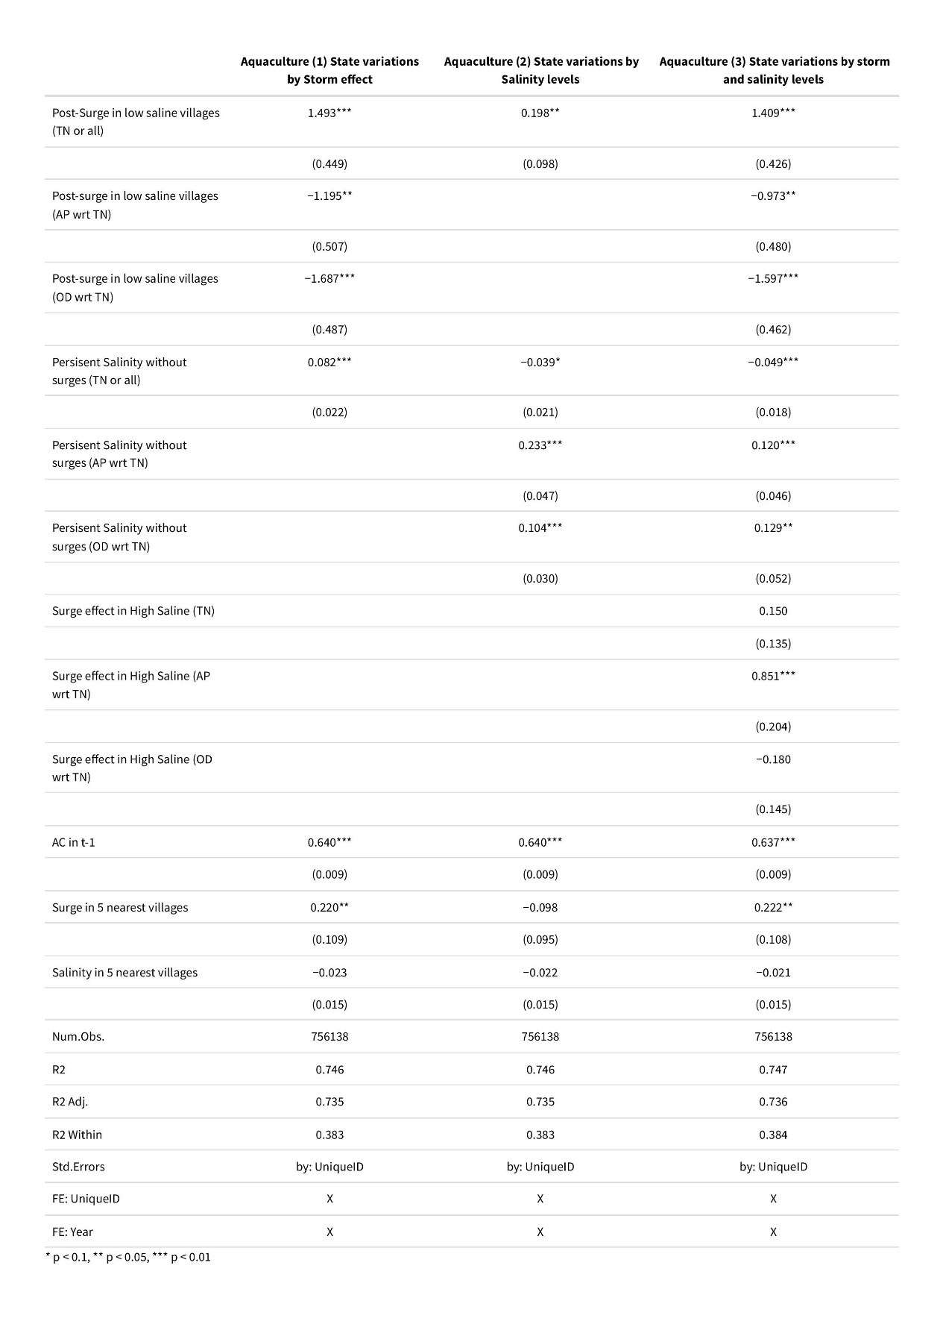

**Supplementary S8: Temporal Heterogeneity of storm and salinity effect on Aquaculture Expansion**

Table : Coefficients of two-way (village and year) fixed effects panel regression model for four time periods: 1990-2000, 2000-2010, 2010-2020, and 2020-2025. Each model has aquaculture land share as the dependent variable, past storm surge effect (binary) and average salinity in last 5 years as the key predictors, place-time varying factors of rainfall and population density as key controls, apart from spatial and temporal lag variables for key predictors and aquaculture respectively, to control for spatial autocorrelation or neighborhood effect. Standard errors are clustered at the village level. Salinity starts out positive, becomes negative, and then weakens. Storms are initially destructive, then adaptive, and then again interact destructively with salinity in more recent times. The salinity and surge interaction flips in importance — from negative early on (barrier), to insignificant (neutral), to strongly negative again post-2020. This suggests compound environmental stressors are increasingly shaping aquaculture decisions. The variable postSurge being dropped in some periods implies low within-village variation — perhaps due to fewer new surge events or high storm clustering. Results are robust with an alternate spatial error correction (Table 5).

Table : Coefficients of two-way (village and year) fixed effects panel regression model for four time periods: 1990-2000, 2000-2010, 2010-2020, and 2020-2025 tested with Conley spatial standard error. Each model has aquaculture land share as the dependent variable, past storm surge effect (binary) and average salinity in last 5 years as the key predictors, place-time varying factors of rainfall and population density as key controls, apart from temporal lag variable for aquaculture. Standard errors are clustered using Conley Spatial Standard Error. Results are robust to an alternate spatial error correction (Table 4).

**Supplementary S9: Differences in Difference and Dynamic Event Study Model**

To estimate the causal effect of storm surge exposure, we implement a dynamic Difference-in-Differences (DiD) with Staggered Treatment Timing using both pooled TWFE models and the Callaway & Sant’Anna (7) estimator. Traditional DiD (Supplementary 12) assumes a uniform treatment effect, but treatment effects often vary across units, time, and cohorts (7–9). For example, villages treated in different years may respond differently, effects may evolve over time (e.g., stronger in year t+3 than t+1), and different regions may exhibit distinct responses to a similar shock. These forms of heterogeneity—and their interactions—require more flexible DiD frameworks to be accurately captured. The dynamic DiD model accounts for variation in timing of treatment (i.e., when villages were first exposed to major storm surges), and dynamic and heterogeneous treatment effects across time and groups.

|  |  |
| --- | --- |
| $${Y (Aqua)}_{it}= δ{({postSurge}_{it} x Treated}_{i})+{β_{1}Salinity}_{i(t-5)}+α_{i} {+ γ_{t}+ ϵ}_{it}$$ | *Eq (2)* |

where the key dependent variable, same as before, is the percentage of village land area under aquaculture. $δ$ is the causal estimate of the treatment and measures causal effect of storm surge on aquaculture after the event (postSurge = 1 for years after the surge, Treated = Villages ever affected). Here salinity and past aquaculture are added as controls, and time and village-level fixed effects applied along with spatial error clustering at the village-level.

Table : A Differences in Differences model with all data included. Key dependent variable is aquaculture land share in a village, and change is estimate before and after a storm. Average salinity over the previous 5-year period is added as a control, and standard errors are clustered at the village level. Villages affected by surge show a +0.121 increase in aquaculture after the surge compared to unaffected villages. Each 1% increase in avg. salinity over past 5 years is associated with a 0.068 pp increase in aquaculture share. The results are consistent with the two-way fixed effect regression model.

Table : A Differences in Differences model disaggregated by states. Key dependent variable is aquaculture land share in a village, and change is estimate before and after a storm. Average salinity over the previous 5-year period is added as a control, and standard errors are clustered at the village level. The surge-effect is particularly strong and significant in Tamil Nadu (+4.2 pp) and Andhra Pradesh (1.016-0.048 =~ +0.968 pp), while the Odisha surge-effect is dropped due to collinearity. Holding other variables constant, the higher average salinity over the past 5 years is associated with lower aquaculture share in Tamil Nadu (TN) (~0.13 pp decrease in aquaculture for each 1 SD increase in salinity). In AP and OD, however, salinity has a positive relationship with aquaculture. In Andhra Pradesh, the salinity effect is 0.623 points higher than in TN, i.e. +0.495, and in Odisha, the salinity effect is +0.159. The results are consistent with the two-way fixed effect regression model.

While our models so far have assessed average effects across space and time, they may obscure important variation by when and where the exposure occurred. To uncover this dynamic structure, we implement a dynamic Difference-in-Differences (DiD) analysis using the Callaway and Sant’Anna estimator (7), which accounts for staggered treatment timing and group-time heterogeneity. This approach allows us to estimate how aquaculture responds in the years before and after villages experience a major storm surge, separately for each cohort of treatment. It also enables comparison across states and treatment years, highlighting whether adaptation patterns differ across contexts or evolve over time. A dynamic event-study model confirms the event-wise differences in adaptation trajectories across different states and years of impact.

Figure 12: Group-Time Average Treatment Effect on the Treated (ATT) by events in different states in coastal India. Each panel corresponds to a different event across the three states, showing how aquaculture outcomes evolved over time following exposure to storm surges. The analysis includes six events post 1990, where the before and after conditions at the village are captured in the database. Of the 6 events, only 4 are represented here, since the ones in 1990 and 1992 captured very little pre-event conditions. Panel (1) is a surge event in 1996 in Andhra Pradesh, Panel (2) in a surge event in 1999 in Odisha, Panel (3) and Panel (4) are surge events in Tamil Nadu in 1993 and 2011 respectively. The vertical lines indicate 95% confidence intervals, and the dashed horizontal line at zero represents no effect.

**Supplementary S10: Effect of past aquaculture on future salinity**

To identify whether the spatial aquaculture expansion contributes to salinization, we estimate fixed-effects panel models where salinity is regressed on lagged aquaculture. Across specifications, we find that increased aquaculture share in one year is associated with significant increases in normalized salinity in the following year. In Andhra Pradesh and Odisha, past aquaculture is positively associated with salinity – indicating possible degradation or intensification effects. Higher past aquaculture, however, is associated with a reduction in salinity in the next period in Tamil Nadu. This could be owing to higher prevalence of freshwater aquaculture in Tamil Nadu, rather than brackish water aquaculture (Supplementary S11).

Table : Effect of past aquaculture on salinity across different states. Key dependent variable is average land share in a village with soil salinity above 1900 µS/cm electrical conductivity (5, 6), and aquaculture land share in the previous year as the key predictor. Past surge effects are added as a control, as well as aquaculture in and surge effects in the 5 nearest neighbors.

**Supplementary S11: Fresh water and Brackish water Production Resources across states (2022)** (10)

Table : Comparing freshwater versus brackish water resources across the three states. Tamil Nadu has about three times the freshwater resources as compared to Andhra Pradesh or Odisha.

|  |  |  |  |
| --- | --- | --- | --- |
|  | **Odisha** | **Andhra Pradesh** | **Tamil Nadu** |
| **Freshwater resources** |  |  |  |
| Rivers and canals (km) | 24,878 | 11,514 | 7,420 |
| Small reservoirs (ha) | 34,608 | 34,693 | 16,059 |
| Medium reservoirs (ha) | 165,771 | 130,898 | 39,030 |
| Other water sources (ha) | 180,000 | 130,000 | **385,870** |
| **Brackish water resources** |  |  |  |
| Tanks and ponds (ha) | 136,951 | **337,438** | 254,518 |
| Brackish water (ha) | **384,950\*** | 54,995 | 56,000 |

* Note: Odisha Brackish water area suitable for culture = 32,587 ha, backwater = 8,100, Brackish water Chillika Lake = 79,000 ha, Estuaries = 297,850

“Tamil Nadu has more freshwater resources than brackish water, and both play a significant role in its aquaculture industry. While the state boasts 56,000 ha of brackish water (6115.68 ha in coastal aquaculture, rest capture fisheries), it has a larger area of freshwater resources, including rivers, lakes, reservoirs, and tanks, totaling about 3.83 lakh ha / 0.38 mil ha. Brackish water aquaculture in Tamil Nadu, while increasing, is still at a smaller scale compared to freshwater aquaculture”.

Source: Tamil Nadu Department of Fisheries, 2024. https://tnfisheries.demodev.in/includes/assets/cms_uploads/pdf/glance/FISHERIES_AT_A_GLANCE_2023-24_9604.pdf

Table : Prevalence of Freshwater and Brackish water aquaculture in the three states (2011-12, 2012-13, 2023-24) (11, 12).

|  |  |  |  |  |  |  |  |  |  |
| --- | --- | --- | --- | --- | --- | --- | --- | --- | --- |
|  | **Odisha** | | | **Andhra Pradesh** | | | **Tamil Nadu** | | |
|  | **2011-12** | **2012-13** | **2023-24** | **2011-12** | **2012-13** | **2023-24** | **2011-12** | **2012-13** | **2023-24** |
| Brackish water aquaculture* area (Ha) | 8,597 | 6,256 | 8,661 | 35,274 | 15,925 | 101,654 | 5,360 | 6,293 | 9,256 |
| Brackish water shrimp production* (MT) | 10,901 | 14,096 | 43,039 | 51,081 | 25,948 | 963,849 | 12,097 | 17,220 | 41,399 |
| Freshwater aquaculture* area (Ha) | 743 | 886 | 1802 | 485 | 280 | 124 | 437 | 136 | 13 |
| Freshwater scampi production (MT) | 513 | 592 | 1339 | 475 | 174 | 100 | 285 | 54 | 6 |

*Note: Brackish water area and production estimates are for Pacific Whiteleg shrimp (L. vannamei) and Black Tiger Shrimp (P. monodon). Freshwater area and production estimates are for scampi only. Other species, notably carps, are not included in the data.

“Scientific farm management in [India] was initiated only in early 1990s, which developed into a major export-oriented sector in subsequent years. However, commercial farming was confined to a single commodity, shrimp, *Penaeus monodon*, and *Penaeus vannamei* due to their high export potential. India has an estimated total estuarine area of 3.9 million hectares; of which, 1.2 million hectares of coastal salt-affected lands have been identified to be potentially suitable for brackish water shrimp farming. Of this, about 15 percent of the potential area has been put into aquaculture purpose… India's aquaculture production basically can be classified into freshwater and brackish water production. There are 429 Fish Farmers Development Agencies (FFDA) and 39 Brackish water Fish Farmers Development Agencies (BFDAs) for promoting freshwater and coastal aquaculture. Some of the important species cultured in India are the Indian major carps and shrimp. ”

Source: Food and Agricultural Organization, 2020. https://www.fao.org/fishery/en/countrysector/naso_india#production (12)

**Supplementary S12: Comparing average state-level wealth across 1990-2025.**

Andhra Pradesh displays more strategic adaptation to both shocks and chronic stressors, while Odisha, despite frequent exposure, shows limited aquaculture growth, likely due to **structural constraints** such as poverty, weak infrastructure, or limited institutional support.

Table : Comparing average wealth quintiles across the three states over the study period. Y-axis represents the average wealth of the households. Evidently, Odisha has structural poverty, with average wealth quintile below 2.5 (WEALTHQHH quintile: 1 = poorest, 5 = richest). Graphic made using DHS India data (available at ddi2-0272a960-5597-013c-327e-0242ac1c0004-idhs_00002.dat-www.idhsdata.org).

**Supplementary S13: Remote-sensing-derived supervised land use classification of aquaculture using Landsat 5 (1990-2012) and Landsat 8 (2013-2025) satellite images.**

**Purpose:** To create a random forest classifier to identify active aquaculture ponds, dry aquaculture ponds, and other land uses on a Landsat Satellite imagery. We use field observations and high-resolution Sentinel 2 imagery for reference data. This supplementary includes the code used, and the accuracy results of the supervised classification.

**Code**: (Google Earth Engine) (13) - 1_LULCClassification_Code.txt

**Landsat 8**

**Hyperparameter tuning for Random Forest Classifier**

Selected 65 trees

Confusion matrix:

[68,1,0],[5,49,1],[3,1,40]]

0: [68,1,0]

1: [5,49,1]

2: [3,1,40]

Overall Accuracy:

0.9345238095238095

Producers Accuracy:

0: [0.9855072463768116]

1: [0.8909090909090909]

2: [0.9090909090909091]

Consumers Accuracy:

0: 0.8947368421052632

1: 0.9607843137254902

2: 0.975609756097561

Kappa:

0.8994066735615917

**Landsat 5**

**Hyperparameter tuning for Random Forest Classifier**

Selected 40 trees

Confusion matrix:

[[72,0,0],[4,29,5],[0,1,48]]

0: [72,0,0]

1: [4,29,5]

2: [0,1,48]

Overall Accuracy:

0.9371069182389937

Producers Accuracy:

[[1],[0.7631578947368421],[0.9795918367346939]]

0: [1]

1: [0.7631578947368421]

2: [0.9795918367346939]

Consumers Accuracy:

0: 0.9473684210526315

1: 0.9666666666666667

2: 0.9056603773584906

Kappa:

0.9010701841712295

**Comparing accuracy outputs with alternate pixel reducers**

The accuracy results with the 30th percentile (listed in the previous section in more detail) are the best among the various reducers tested, closely followed by the geometric median. For the CoSal-SA model, we have employed the geomedian.

We preferred geomedian reducer over percentile for three reasons (14): (1) it enables stacking multiple images of varying quality to a high-quality pixel composite while reducing spatial noise, (2) in contrast to a median reducer, a geomedian also helps maintain spectral relationship between bands and consistency across scene boundaries, and (3) it is a recommended method to maintain spectral relationships between bands when further analysis on the composite image is required, such as applying a machine learning algorithm. We have also adopted geomedian reducer to qualify using the machine-learning based model developed by Perikamana et al. (15) to harmonise Landsat 5 TM  images with Landsat 8 OLI (16).

|  |  |  |  |  |
| --- | --- | --- | --- | --- |
| **Accuracy measure** | **Percentile (30)** | **Geometric median (adopted)** | **Median/Percentile (50)** | **Percentile (70)** |
| Overall accuracy | 0.96 | 0.94 | 0.92 | 0.90 |
| Kappa | 0.93 | 0.91 | 0.88 | 0.84 |
| Producers accuracy | 0: [0.95]  1: [0.95]  2: [0.98] | 0: [0.95]  1: [0.93]  2: [0.94] | 0: [0.97]  1: [0.85]  2: [0.90] | 0: [0.95]  1: [0.80]  2: [0.90] |
| Consumers accuracy | 0: [0.96]  1: [0.91]  2: [1] | 0: [0.95]  1: [0.93]  2: [0.94] | 0: [0.92]  1: [0.85]  2: [0.98] | 0: [0.91]  1: [0.86]  2: [0.91] |

|  |
| --- |
|  |
|  |
|  |
|  |

Figure : Supervised Land Use Land Cover classification. Using a Sentinel-2 composite (top) as a visual reference and field observation points for 274 active aquaculture points, 220 dry/abandoned aquaculture points, and 391 non-aquaculture or other uses, a classifier is trained using the Landsat 8 composite (middle). The trained classifier is applied to Feb 2024 (bottom) and historical Landsat composites. The satellite images are extracted using Google Earth Engine (13).

**Supplementary S14: Surge events**

Environmental shock impact of storm surges using SURGEDAT data base that documents all surge events from 1880-2015 (2)

Table : SURGEDAT database for Coastal India (2)

Figure : Locations of historical storm surges recorded from 1880-2015

|  |  |
| --- | --- |
|  |  |

Figure : Process for modelling storm surge affected villages illustrated using the district Nagapattinam in Tamil Nadu. Depth and width of each storm is estimated using EM-DAT (17) database and secondary sources and a buffer is created (left panel). Minimum surface elevation is used as a measure whether a village is affected or not. Digital elevation model data is illustrated in the right panel (18). If the minimum elevation is below the surge height, and the village falls within the affected area buffer, then the effect is counted as 1 else 0. This is repeated for all surges in the study area (events considered starting 1964).

**Supplementary S15: Discontinuity analysis for sensor differences in two time periods**

Since this database integrates aquaculture and salinity data using two distinct Landsat satellite sources (Landsat 5 and 8), a discontinuity assessment was undertaken to ensure there are no residual differences due to satellite sensor differences.

1. **Salinity**

lm_discont <- lm(Saline_perc ~ Year + I(Year >= 2013), data = aqua_salinity_surge)

summary(lm_discont)

|  |
| --- |
| Residuals:  Min 1Q Median 3Q Max  -9.843 -7.168 -2.589 -0.807 94.943  Coefficients:  Estimate Std. Error t value Pr(>|t|)  (Intercept) 211.087856 4.434209 47.60 <2e-16 ***  Year -0.101128 0.002216 -45.64 <2e-16 ***  I(Year >= 2013)TRUE -4.321616 0.047249 -91.47 <2e-16 ***  ---  Signif. codes: 0 ‘***’ 0.001 ‘**’ 0.01 ‘*’ 0.05 ‘.’ 0.1 ‘ ’ 1  Residual standard error: 11.89 on 876418 degrees of freedom  (242747 observations deleted due to missingness)  Multiple R-squared: 0.06397, Adjusted R-squared: 0.06397  F-statistic: 2.995e+04 on 2 and 876418 DF, p-value: < 2.2e-16 |

This captures salinity percentage (Saline_perc) as a function of the year (to capture the trend) and a binary dummy (I(Year >= 2013)) that captures the effect of the Landsat sensor switch. There's a strong structural break in the salinity values starting in 2013, likely due to the switch from Landsat 5 to Landsat 8 despite the harmonization. Salinity declines by about 0.1 percentage point per year on average, all else equal. After 2013, salinity values drop by 4.32 percentage points on average, even after controlling for the time trend. This suggests that the Landsat 5 and 8 models are not on the same scale.

We therefore, **normalize salinity** by sensor period. This will remove level differences between periods, but will retain within-period variation. Z = (x-mean)/SD.

aqua_salinity_surge <- aqua_salinity_surge %>%

mutate(period = ifelse(Year <= 2012, "L5", "L8")) %>%

group_by(period) %>%

mutate(Saline_perc_norm = scale(Saline_perc)) %>%

ungroup()

str(aqua_salinity_surge$Saline_perc_norm)

aqua_salinity_surge$Saline_perc_norm <- as.numeric(aqua_salinity_surge$Saline_perc_norm)

str(aqua_salinity_surge$Saline_perc_norm)

summary(aqua_salinity_surge$Saline_perc_norm)

|  |
| --- |
| Min. 1st Qu. Median Mean 3rd Qu. Max. NA's  -0.60 -0.51 -0.33 0.00 -0.08 12.20 242747 |

This is a standardized measure centered at 0. Values are also -ve here because of z-score standardization, which centers the data around 0 within each sensor period.

All interpretations to be read as: ***A one standard deviation increase in salinity (relative to the Landsat period's mean) is associated with a x percentage point increase/decrease in aquaculture land area percentage, holding storm and year constant***.

|  |
| --- |
| > mean_salinity_perc_13_25  [1] 2.5775  > sd_salinity_perc_13_25  [1] 7.766171 |

1. Aquaculture

> lm_discont <- lm(Aqua_perc ~ Year + I(Year >= 2013), data = aqua_salinity_surge)

> summary(lm_discont)

|  |
| --- |
| Residuals:  Min 1Q Median 3Q Max  -1.527 -1.258 -0.903 -0.582 98.431  Coefficients:  Estimate Std. Error t value Pr(>|t|)  (Intercept) -4.566e+01 1.714e+00 -26.630 <2e-16 ***  Year 2.322e-02 8.567e-04 27.107 <2e-16 ***  I(Year >= 2013)TRUE 1.551e-01 1.825e-02 8.502 <2e-16 ***  ---  Signif. codes: 0 ‘***’ 0.001 ‘**’ 0.01 ‘*’ 0.05 ‘.’ 0.1 ‘ ’ 1  Residual standard error: 4.629 on 886146 degrees of freedom  (233019 observations deleted due to missingness)  Multiple R-squared: 0.004578, Adjusted R-squared: 0.004575  F-statistic: 2038 on 2 and 886146 DF, p-value: < 2.2e-16 |

A statistically significant but very small upward trend over time in aquaculture land share (0.023 percentage point per year). The coefficient for the sensor break (post-2012) is small and not statistically significant. This implies there is no evidence that aquaculture values jump discontinuously at 2013.

Aquaculture does not have discontinuity at 2013, and need not be normalized.

**Supplementary S16: Causal relationships between surge, salinity and aquaculture**

Figure 16: Directed causal diagram. This depicts the causal relationship between surge (S) and outcome of aquaculture land change (Y1), through mechanisms like salinity (M1) or state recovery and policy responses (M2), in the presence of other confounding observed and unobserved (OU) variables, such as place-based variations like distance or elevation from the sea or soil type. There could be other external factors (P1), such as international market demand or price inflation shocks, that may also affect the uptake of aquaculture. We are further interested in the second part of this causal diagram, depicting the potential causal connection between this aquaculture shift in time 1 (Y1), on future salinity (Y2).

**Supplementary S17: Cyclonic Storm Hazard Exposure** (19)

The western coastline of India is equally exposed to cyclonic storm and associated surge risk; any part of the coastline being hit by a storm surge or not in the past is a random event.

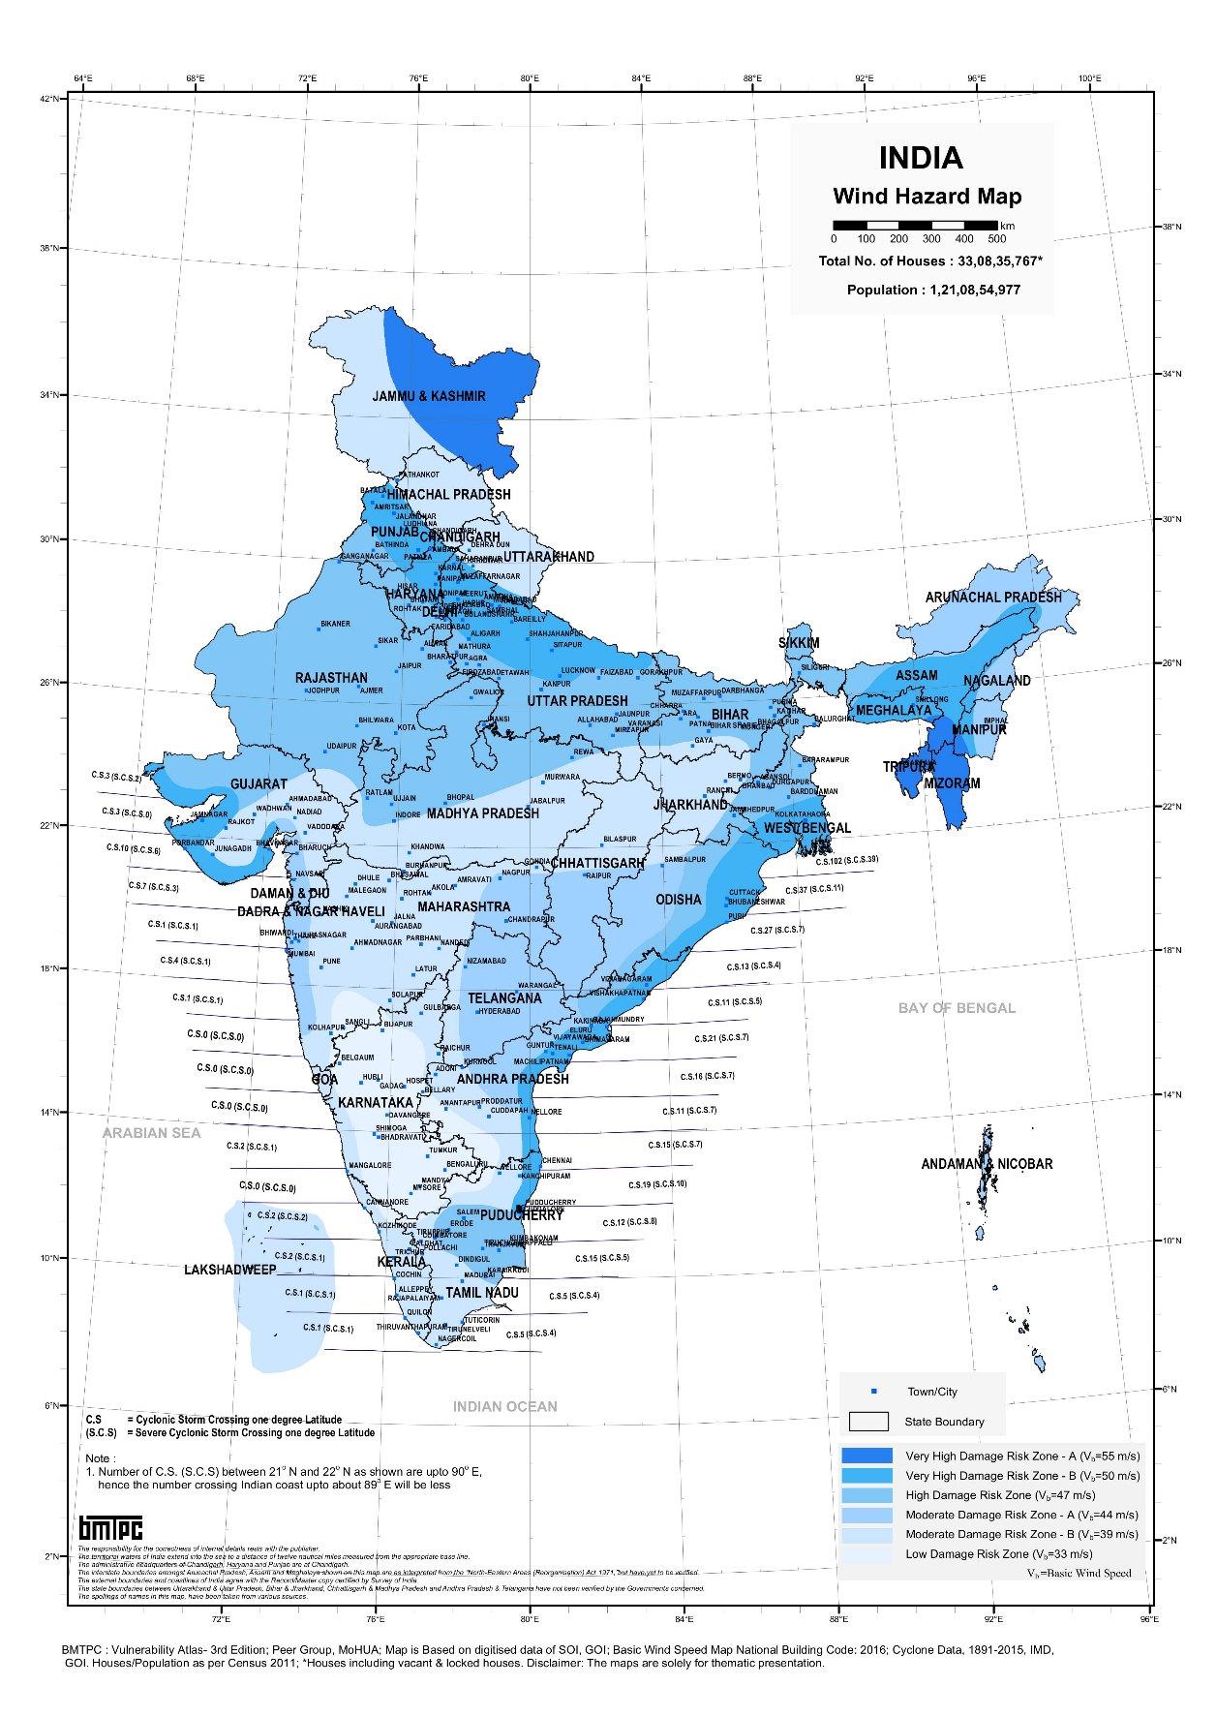

Figure : Cyclone exposure map of India. This shows equal exposure of “Very High Damage Risk” to the western coastline of the country, with the exception of southern part of Tamil Nadu, that has “High Damage Risk”.

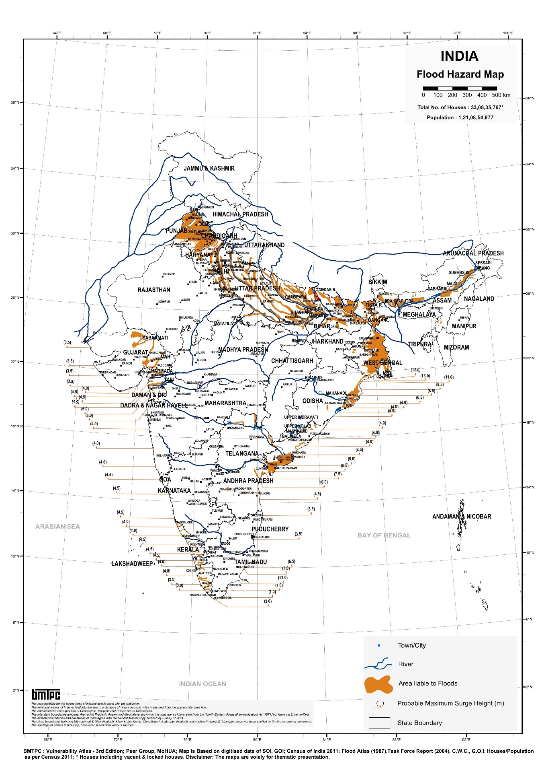

Figure : Flood and Surge Height Exposure Map of India. This shows that while the entire coast is equally susceptible to surges, the surge heights they are exposed to vary. These surge height variations are accounted in the surge effect modelling based on land surface elevation and surge heights of the events (Supplementary S14). Source: BMTPC, 2019 (19).

**References**

1. Census of India, India Village and Town Boundaries 2001. Available at: https://sedac.ciesin.columbia.edu/downloads/metadata/india-india-village-level-geospatial-socio-econ-1991-2001.html [Accessed 13 July 2025].

2. SURGEDAT: THE WORLD’S STORM SURGE INFORMATION CENTER. Available at: https://surge.climate.lsu.edu/data.html#GOM_DB [Accessed 12 July 2025].

3. K. Prasad, M. Ottinger, C. Wei, P. Leinenkugel, Assessment of coastal aquaculture for India from Sentinel-1 SAR time series. *Remote Sens. (Basel)* **11**, 357 (2019).

4. FAO, FishStat. *FAO Fisheries and Aquaculture* (2015). Available at: https://www.fao.org/fishery/en/fishstat [Accessed 28 November 2023].

5. G. Jain, W. Yang, S. Sarkar, D. S. C. Amy Frazier, CoSal: A remote sensing and machine learning framework for mapping coastal soil salinity trends around aquaculture in South Asia. *Res. Sq.* (2025).

6. S. R. Grattan, L. Zeng, M. C. Shannon, S. R. Roberts, Rice is more sensitive to salinity than previously thought. *Calif. Agric. (Berkeley)* **56**, 189–195 (2002).

7. B. Callaway, P. H. C. Sant’Anna, Difference-in-Differences with multiple time periods. *J. Econom.* **225**, 200–230 (2021).

8. L. Sun, S. Abraham, Estimating dynamic treatment effects in event studies with heterogeneous treatment effects. *J. Econom.* **225**, 175–199 (2021).

9. N. Huntington-Klein, *The Effect: An Introduction to Research Design and Causality*, N. Huntington-Klein, Ed. (CRC Press, 2023).

10. Department of Fisheries, “Handbook on Fisheries Statistics” (Department of Fisheries, Ministry of Fisheries Animal Husbandry & Dairying, Government of India, 2022).

11. MPEDA, State-wise Aquaculture Production. *MPEDA* (2024). Available at: https://mpeda.gov.in/?page_id=651 [Accessed 18 August 2025].

12. India - National Aquaculture Sector Overview. Available at: https://www.fao.org/fishery/en/countrysector/naso_india#production [Accessed 15 August 2025].

13. N. Gorelick, M. Hancher, M. Dixon, S. Ilyushchenko, Google Earth Engine: Planetary-scale geospatial analysis for everyone. *Remote Sens. Environ.* (2017).

14. D. Roberts, N. Mueller, A. Mcintyre, High-dimensional pixel composites from earth observation time series. *IEEE Trans. Geosci. Remote Sens.* **55**, 6254–6264 (2017).

15. Perikamana, K.K., Parath, N., & Balakrishnan, K., *An improved method for harmonizing Landsat 5-TM and Landsat 8-OLI data.* *(Manuscript in preparation)* (2025).

16. D. M. Jennewein, *et al.*, The sol supercomputer at Arizona state university in *Practice and Experience in Advanced Research Computing*, (ACM, 2023).

17. D Guha-Sapir, R. Below, P. Hoyois, EM-DAT International Disaster Database. Available at: https://public.emdat.be/data.

18. Copernicus, Copernicus DEM GLO-30: Global 30m Digital Elevation Model. *Google for Developers*. Available at: https://developers.google.com/earth-engine/datasets/catalog/COPERNICUS_DEM_GLO30 [Accessed 12 July 2025].

19. BMTPC, Flood Hazard Map. *BMTPC* (2019). Available at: https://vai.bmtpc.org/flood.html [Accessed 14 July 2025].